**KERALA STATE DISASTER**

**MANAGEMENT APPLICATION**

1. Introduction to KSDMA-

The state is frequently ravaged by the disastrous consequences of coastal erosion, lightning, landslides, floods, drought and petro-chemical transportation related accidents. Kerala State Disaster Management Application Project is aimed at effective event management of resources in case of any disaster and emergency. This solution aims at effective management of multiple Emergency incident and events and help officials take informed decisions.

**Overview of the Solution provided to KSDMA-**

Kerala State Disaster Management Application will be built by integration of IBM Intelligent Operations Centre [IOC] and ESRI.

In case of any emergency an event will be generated on IBM IOC. Once the event has been generated the operators will receive alerts and notifications on a common dashboard. Alerts will also be sent to higher officials, management and stake holders. Notification will be in form of Email or SMS alert. Once an event is reported on IOC the operator will then co-ordinate with multiple departments to perform the related Standard Operating Procedures. Operators can filter down the nearby resources like ambulance, Fire bridges, hospitals, schools etc to quickly locate the nearby resource and take the necessary actions. SOP’s can be triggered manually or automatically. The alerts which are reported at the call-centre by calls can be triggered manually and operators will then follow the SOP’s to effectively manage the emergency situation. Alerts which are triggered by the system will be populated into IBM IOC and the SOP’s will be triggered. IBM IOC reporting generation service can be used to generate the report of the events which are generated and the SOP’s that was followed to close the event. IBM IOC Knowledge performance indicators will be used to know the performance in case of any emergency event and which can be used to take necessary actions to optimize the system.

The rainfall, landslide, earthquake, tsunami data will be mapped on ESRI map using arcgis. Further analysis and perditions can be done on ESRI server that will give us predictive models such as flooded area in case of heavy rain fall. These predictions will help to take necessary actions to preserve important assets and effectively take necessary actions during an emergency.

**Rainfall Module:**

In process to start the prediction of emergencies actual and predicted rainfall values are required. To get rainfall values use Numerical Weather Prediction (nwp) division by using the following link [*http://nwp.imd.gov.in/gfsproducts.php*](http://nwp.imd.gov.in/gfsproducts.php)

Here rainfall values are in the form of image files where each colour indicates different rainfall value as per the legend index.

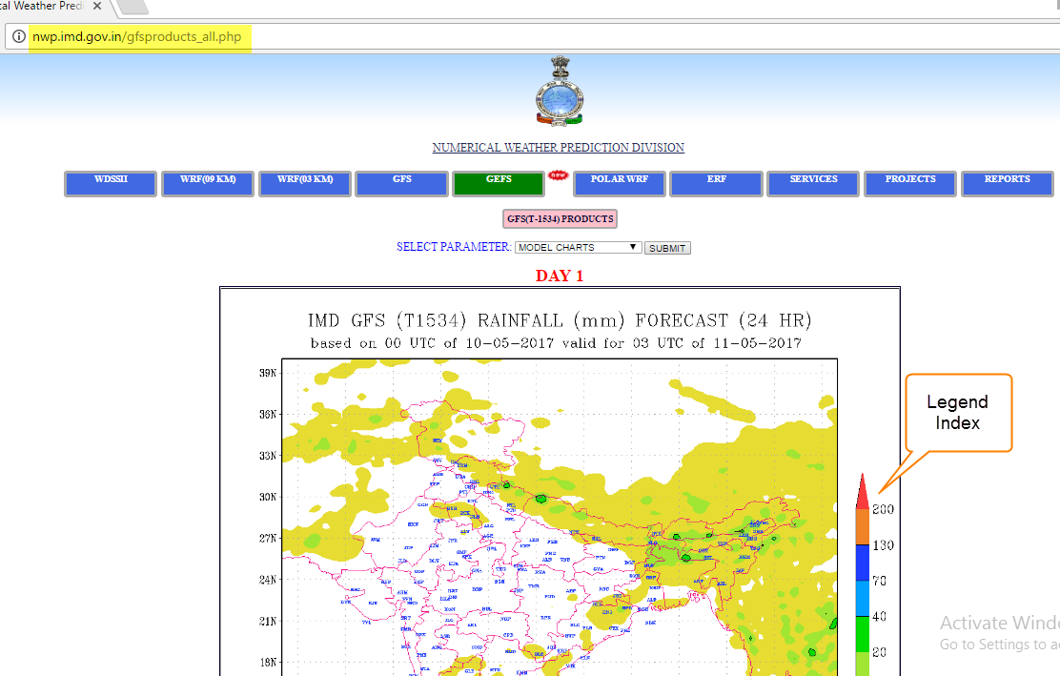

*Fig 01: link to download rainfall value image files*

Out of these image files download image files of current date and next date to get Today’s actual and Tomorrow’s predicted rainfall values.

Store today’s rainfall image file with the name as current date and tomorrow’s rainfall image file with the name as next date In the directory named as current date with DD-MM-YYYY format.

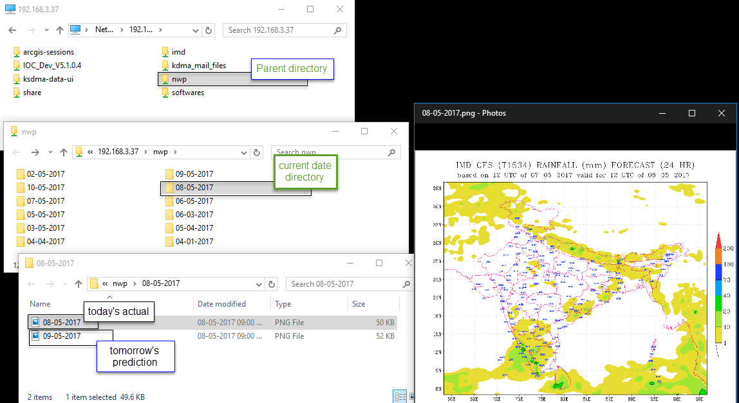

*Fig 02: showing directory structure.*

After downloading required files ESRI Arcgis software is used for GeoReferencing.

**Arcgis Flow:**

*Required software:*

* Arcgis Desktop10.4
* .net_framework-4.5.1
* Silver light
* Visual Studio

*Workflow:*

Create a directory as “C:\KSDMA_ESRI\Workspace” and store both image files there. Use the same directory location for automation process in python script. After storing the files start GeoReferencing process with following steps.

1. Add data(Rainfall image file and Kerala shape file) to arcgis software

Open Table of Contents by “Windows> Table of contents> Right click Layers> Add data> select required files> Add.

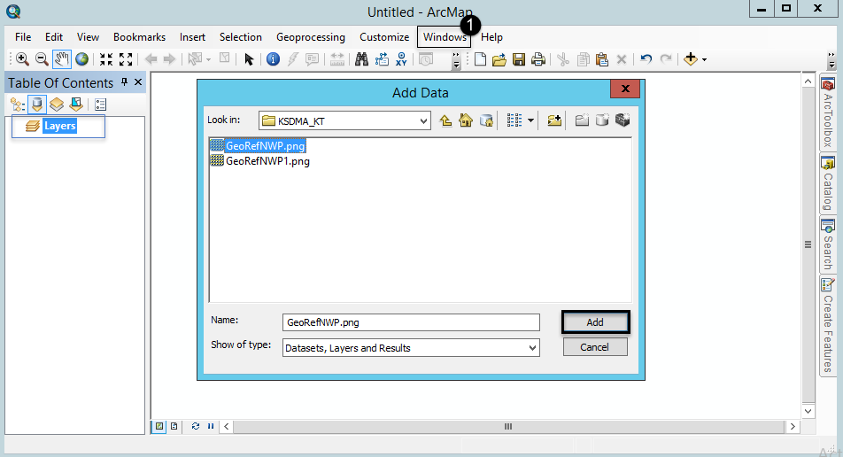

*Fig 03: Adding data to arcgis*

1. Add GeoReferencing toolbar by Customize> Toolbars> check GeoReferencing.

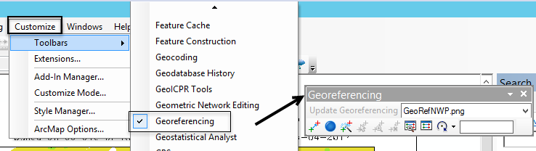

*Fig 04: add GeoReferencing toolbar*

1. GeoReferencing process

Start GeoReferencing by adding control points from .png raster file to Kerala shape file. After completion of GeoReferencing update it by clicking on update GeoReferencing button in GeoReferencing toolbar.

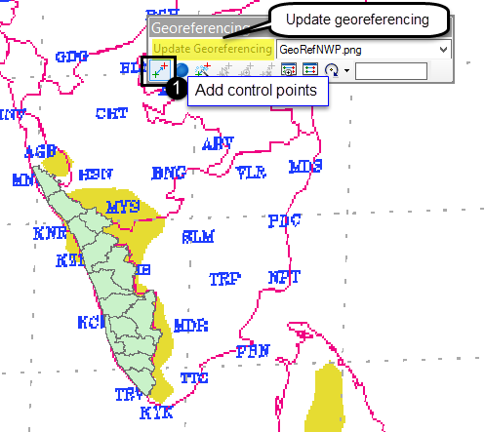

*Fig 05: GeoReferencing*

These are the output files from GeoReferencing. GeoReferencing is one time process only.

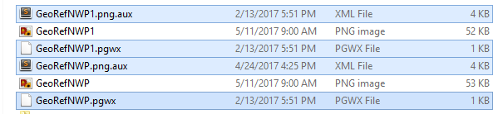

*Fig 06: Output files from GeoReferencing.*

Till this step the manual processing of GeoReferencing is completed. The extracted output files will be stored in Default.gdb Geo database. Use these extracted output files for automation.

For automation the location of Default.gdb and workspace is mentioned in python script.

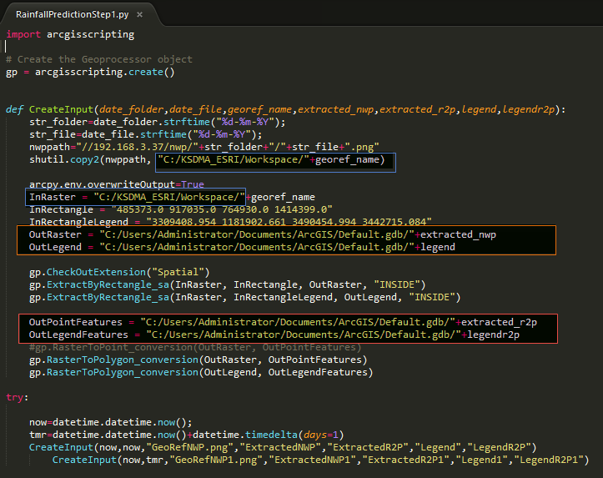

*Fig 07: Python script for automation.*

Next create a batch file with KSDMA.bat name and store the location of Python script.

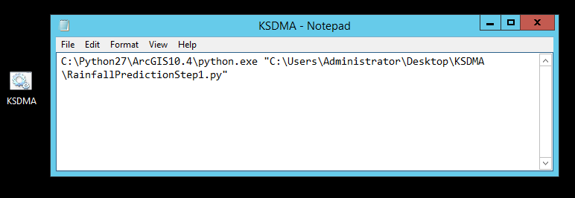

*Fig 08: KSDMA.bat file*

All the process done till now, have to be repeated for everyday to get updated rainfall value. For this purpose use this bat file. There are two ways to run this bat file either by running it manually every day or by scheduling it to Task scheduler so that it can get executed automatically every day at scheduled time.

1. Create KSDMA toolbox in Arcmap

Windows> Catalog> Toolboxes> my Toolboxes> Right click> new> Toolbox> KSDMA.tbx

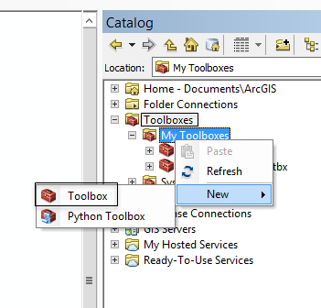

*Fig 09: Creating KSDMA toolbox.*

1. Add Rainfall Prediction tool to KSDMA.tbx

Right click KSDMA.tbx> Add> Tool> check Rainfall Prediction tool

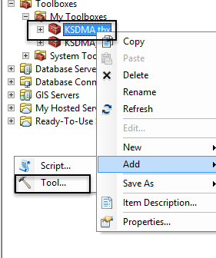

*Fig 10: Adding Rainfall Prediction Tool.*

Next double click Rainfall prediction tool to start rainfall prediction for current day and next day.

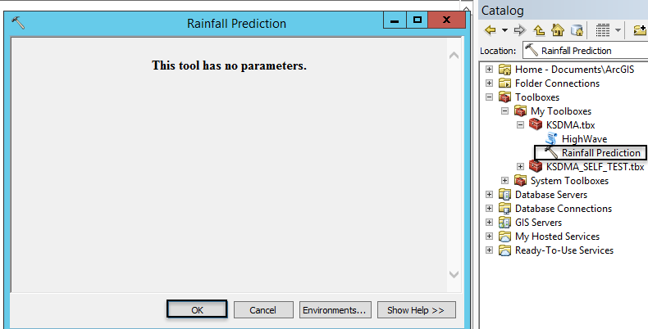

*Fig 11: Run Rainfall prediction tool*

Rainfall prediction tool includes .net code which is having all required methods and functions will get executed every day at pre scheduled time to complete the prediction.

Store predicted rainfall data in database

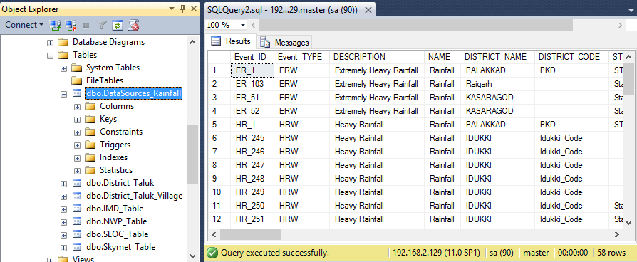

*Fig 12: Predicted data in database.*

This data will be used in IOC to generate alerts.